Ideation Phase
Define the Problem Statements

Date | 31 January 2025
Team ID | LTVIP2026TMIDS42870
Project Name | electric motor temperature prediction using machine learning
Maximum Marks | 2 Marks

Customer Problem Statement Template:
Create a problem statement to understand your customer's point of view. The Customer Problem Statement template helps you focus on what matters to create experiences people will love.
A well-articulated customer problem statement allows you and your team to find the ideal solution for the challenges your customers face. Throughout the process, you’ll also be able to empathize with your customers, which helps you better understand how they perceive your product or service.
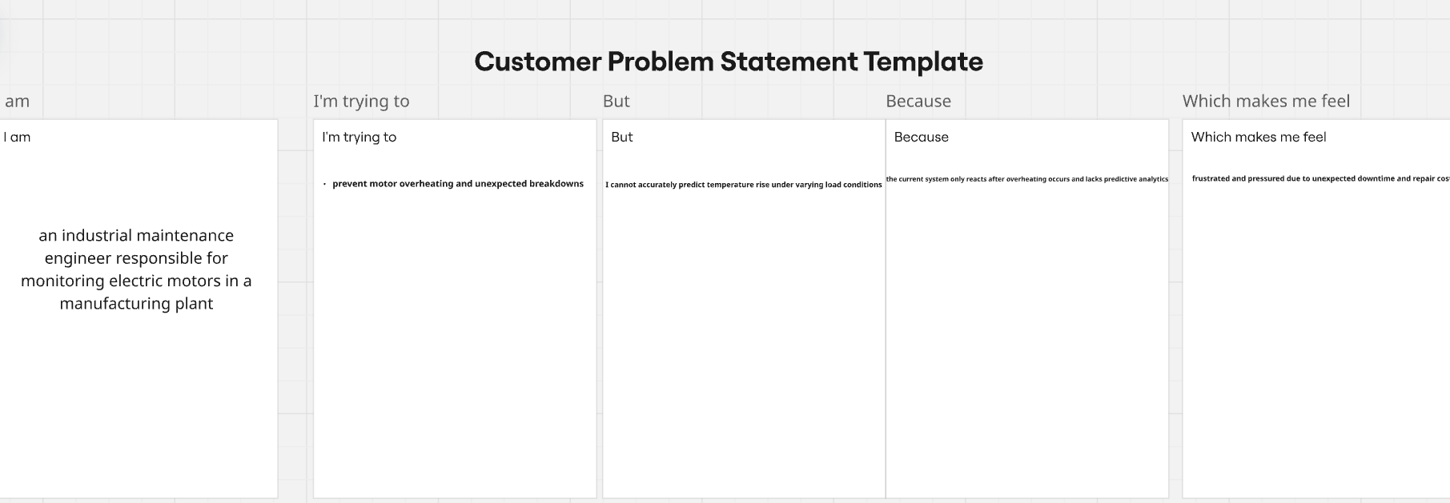
Reference: https://miro.com/templates/customer-problem-statement/
Problem Statement (PS) | I am (Customer) | I’m trying to | But | Because | Which makes me feel
PS-1 | an industrial maintenance engineer | prevent motor overheating and unexpected breakdowns | I cannot accurately predict temperature rise under varying load conditions | the current system only reacts after overheating occurs and lacks predictive analytics | frustrated and pressured due to unexpected downtime and repair costs

